Darshan Patel | 0365326

Project Report

LDA & Word2Vec for semantic Analysis

Abstract:

Yelp is a decent wellspring of surveys for clients, which enable them to pick the best business in the area. The dataset is a subset of businesses, users, tip, photos, checkin and review data which provides a platform to learn about various techniques like Data Mining, NLP, ML etc. to discover patterns, analyse textual data and find meaningful information. This project will focus on providing an overview of how can LDA and Word2Vec can be used for Semantic Analysis. Topic modelling techniques were developed to discover different topic dimensions of a document set. This paper will document the evaluation of two different techniques LDA and Word2Vec on yelp dataset & Enron Email Dataset followed by analysing the results obtained to learn which technique is better for semantic analysis and which is better for sentiment analysis and why.

I) Introduction:

A semantic analysis is intended to discover the meaning of structured and relevant information from the data. Semantic search provides more meaningful search results by evaluating and understanding the search phrase and finding the most relevant results. The goal of the project is to implement Latent Dirichlet Allocation (LDA) and Word2vec techniques for Semantic search on Yelp dataset and Enron Email dataset. Based on results from these 2 techniques, analyse which of these techniques is suitable for Semantic analysis and which one is for Sentiment analysis.

II) Techniques/Approaches:

Latent Dirichlet Allocation (LDA): It is one of the most common topic modelling techniques. It can be understood via 2 principles. First, every document is a mixture of topics and second, every topic is a mixture of words. So basically, LDA is used to estimate both the principles at the same time. LDA will be useful in determining which words exactly belong to a specific topic and then it will determine the topic of document by then examining its probabilities. In order to work with LDA, document term matrix is required. So, first a document term matrix, which is a matrix describing the frequencies of terms that occurs in a corpus, will be calculated. In DTM, rows correspond to documents and columns corresponds to terms.

Word2Vec: The word2vec technique is used to produce word embeddings. It is a tool which provides an efficient implementation of the continues Bag-Of-Words and Skip-gram architecture for computing vector representation of words. Word2Vec tool takes a large text corpus as input & produce the word vector as output. It first constructs a vocabulary from the training text data and learns vector representation of words. Each unique word in corpus is assigned a vector in space. These word vectors are positioned in such a way that words that share common contexts in corpus are in the closer proximity to one another in the space. We are using it to find closet words for a user-specific words.

III) Packages and Dataset:

Programming Language/Packages: This project will be using R which provides a great environment for data mining, statistical computing and graphics. R can be easily extended by using available packages at CRAN, thus making implementation easy.

Packages - the packages which will be used are : Text Mining(tm), Natural Language Processing(NLP), Wordcloud, jsonlite, Latent Semantic Analysis(lsa), RTextTools, ggplot2, SnowballC, e1071(For latent class analysis, Naive-Bayes classifier, SVM etc.), Plotly, cluster, factoextra, topicmodels, word2vec, word_analogy.

Data Source:

Link : (https://www.yelp.com/dataset/challenge)

Yelp Dataset:

The dataset is obtained from 11th round of ‘Yelp Dataset Challenge’ and contains information about local businesses in 12 metropolitan areas across 4 countries, with around 156639 businesses and 5 million reviews from over 1.1 million users. The dataset downloaded is of 5.79 GB which contains 6 files in JSON format (user, business, review, checkin, tip, photo). This project will be focusing on 2 out of 6 files which are business.json and review.json. 100k reviews was taken from Restaurant category with cuisines as subcategory namely, Chinese, French, Indian, Italian and Mexican with 20k records each. 100k reviews was also used for the experiment.

Enron Email Dataset: This dataset is consist data from 150 users, mostly from the senior management of Enron Corporation. The dataset is basically took from the email communication of Enron Employees. Email were extracted and each mail were stored into different text file, total 137k emails were extracted and 100k records was used for the experiment.

IV) Approach:

Extraction: From both of the dataset total 100k records we took and store it into CSV and TXT format.

Pre-processing Steps:

Yelp dataset is originally in JSON format which will be first converted to .csv format before pre-processing it. In order to do that, library jsonlite was used. With the help of stream_in() I was able to read JSON data, which took hours to read it. Then the JSON data was flatten into regular 2 dimension tabular structure, which was then checked if it was a data frame object using as.data.frame(). Once I was sure data is ready, business_Id and categories was extracted from business.json and business_Id and text was extracted from review.json. I perform the following task for data pre-processing:

-Stopwords,stopwords_en, whitespace, numbers and punctuations were removed using the tm package which cleans the raw data and prepare data for further analysis.

-I created Document term matrix by using the inbuilt DocumentTermMatrix(). This matrix describes the frequency of terms which occurs in a document.

- dtm<-DocumentTermMatrix(corp, control = list(wordLengths=c(4, Inf)))

-Stemming was performed on the cleaned data because the classifier doesn’t understand verbs and treats them as different words.

-Pruning words by frequency: words that occurs in very few documents were removed, which is good because the entire focus is on the words which have high frequency and it also reduces computation time.

-I also remove the sparse terms so that the whole pre-processing will be done.

- Experiments: Implementing LDA:

After pre-processing data and getting document term matrix in previous steps, we are now ready to perform LDA. In order to do so, we used Gibbs sampling for estimation. The main parameters for LDA are as follows:

  - burnin - starting period, steps which does not reflect distribution property are removed.

  - iter - number of iterations

  - thin - number of iteration at which correlation between samples is avoided

- seed - an integer for each starting point

- nstart - number of runs at different start points

- best - return result of best run

LDA(dtm, 4, method="Gibbs", control=list(nstart= 5, seed = list(2003,5,63,100001,765), best= TRUE, burnin = 4000, iter = 1000, thin= 500))

Implementing Word2Vec:

We used inbuilt functions of Word2Vec. For work with Word2Vec we have to give text corpus as a input file and we will get binary file as output. As rword2vec package requires the single text file as an input for training a model, I had to combine all 100k text files into a single text file. This resulting file consists of all 20,000 reviews which were extracted.

- word2vec(train_file =” ” , output_file =” ” , binary=1)

- train_file: path of the text file which will be used as a training file to create the vocabulary

- output_file: path for the word2vec output file in a binary format

Parameter Tuning:

As should be obvious from above area, LDA capacities have a few parameters. I have utilized default parameters to get the outcome, yet couple of parameters can be tuned to get enhanced outcomes. Parameters, for example, iter, k, nstart can be tuned to get enhanced outcomes. Be that as it may, tuning them to the extraordinary can be awful as far as calculation.

Iter : in the event that we set it too high then it might bring about the great model yet it will cost more on calculation particularly in situations where corpus is immense.

nstart: like iter, if the esteem set too high then it will have more computational cost.

- if the esteem is set too low then we won't not get every single dormant theme. On another hand, if the esteem is set as well high then we may make them astound subjects which may not bode well. The site without moving quality will be the no of classes or distinctive kinds of information in the corpus. We can simply perform examination on points made with various qualities and figure out which ought to be the site esteem.

VI) Results & Analysis:

Results for Yelp Dataset:

LDA executed for a different number of values for parameter k. k= 3,4,5,6,10,50,100 and 200 was used to get different results. I used 100k records for this.

Following table indicates the top 10 words for that topic when k=5 ,100 and 200.

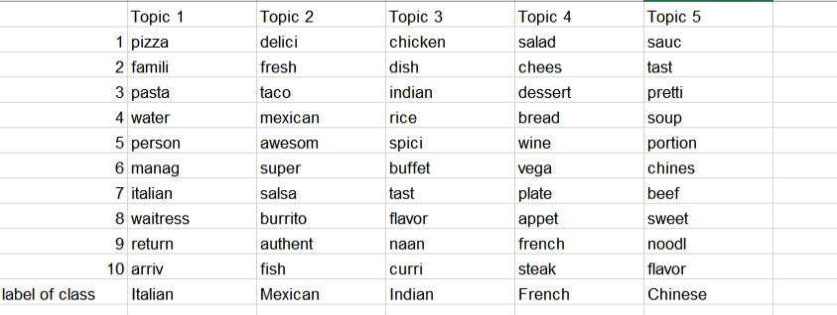

For k=5

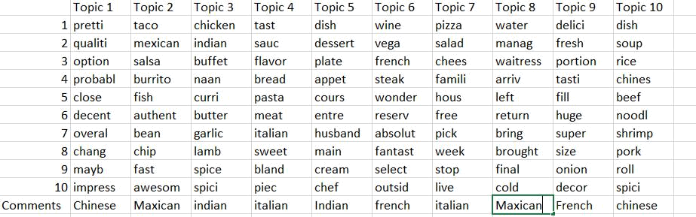

For k=10

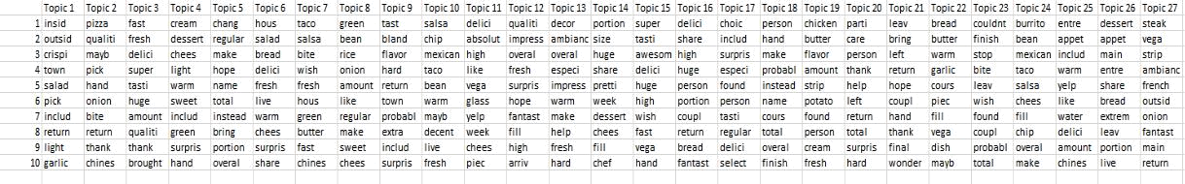

For k=100

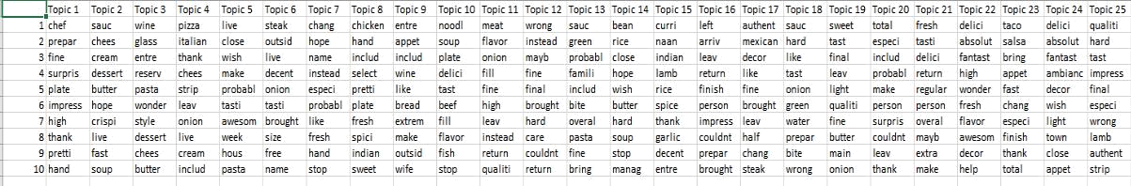

For k=200

The results indicate the various topics present in the dataset. As shown in the comment, each topic belongs to a specific category in all of the cases. As reviews are common except the cuisine, I see some of the common words in each of the topics which may not belong to specific cuisine/category. LDA does a good job in identifying the terms belonging to specific category i.e. cuisine. For e.g., Pizza and Pasta for Italian cuisine; Taco, Burrito for Mexican cuisine and so on. As I increased the value for k, I observed that some words were part of few topics instead of one. Also, the topics with general terms were increased. Moreover, we can see that as we use more records we can get accurate results. For less records terms can be repetitive but when you are using more record it will be easier to label the class according to the topic. As our sample dataset is for food reviews, we can see many common terms such as quality, atmosphere, options, services, etc in each of the 5 topics. So, when we executed LDA with k=6 and 10, the common terms were identified and put together as different topics along with original 5 category topics. When K further increased to 50,100 and 200, we observed resulting topics started containing more common terms and some terms were part of multiple topics.

Here are some sample reviews which we have in review.json file and extracted.

“I ordered the Tandoori Chicken and also the garlic rice and garlic bread with a side order of gulag. Everything was really good. “

“The service started off super attentive. My glass would reach half full and it would be filled again before I noticed. By the time we were winding down the service disappeared unless we waved, called and made efforts to squire attention. “

Word2Vec:

I train the text file of yelp dataset of the cuisine that we choose and then I try to search words and figure out top 20 words which are similar with that words. I try it for different words and I give 10 words from that 20 words. The results are as below:


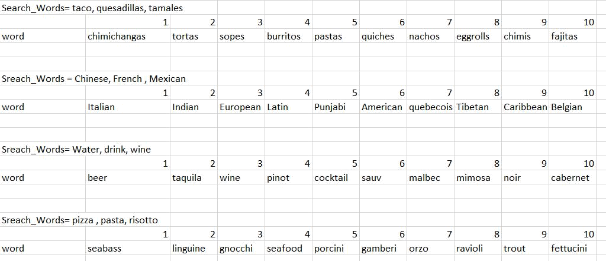

For the search words “tacos, quesadillas, tamales” We can see here, word2vec did a good job in identifying the different type of dishes from different cuisine, as we get the dishes from Mexican, French, Indian, here I show only some dishes from the result. when we search for the words “wine, water, drink” it is giving perfect output as different type of wines, beer, cocktails.

When I search for the words “Chinese, French, Mexican” it gives me output of words like Italian, Indian, Tibetan and many more which are different type of cuisine like the search words so word2vec did a great job. When I search for words like “pizza, pasta, risotto” then I got the dishes like seabass, trout, porcini which all are Italian dishes so again I got the great results of Italian dishes when I give input of Italian dishes.

Word2vec does a good job in identifying words used in similar context i.e. Indian cuisine - Mexican cuisine, drink wine – drink beer, etc. In contrast to LDA, word2vec doesn’t provide any words which belong to the same category as an input word. This can be observed in the first example given above.

The main result which I got is as below from which I give above result of 10 words. It is one of the 4 results.

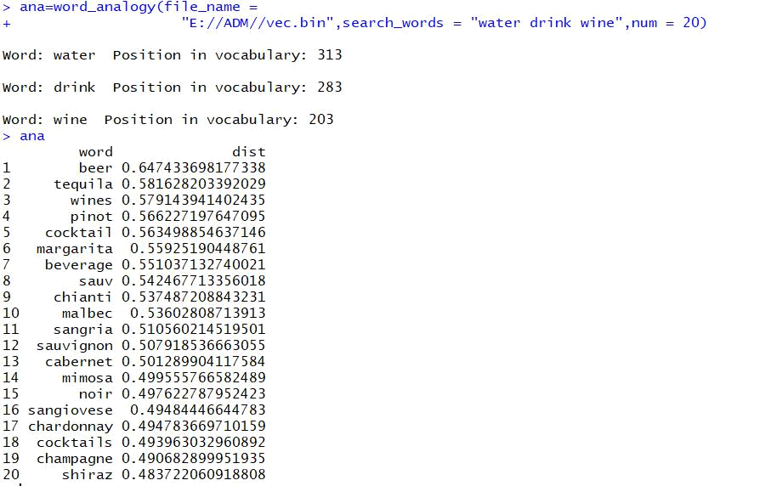

Similarly I got results for the other search word

Enron Email dataset:

Sometimes it becomes tuff to give labels to the topics when your dataset does not contain any and we don’t have information about that. Same thing happens in Enron Dataset I run LDA on the Enron dataset for high records and here is the output for the k=5 and top 10 words. First, I extract data from Enron dataset for which I do python code and extract every email id and store it in different text files.

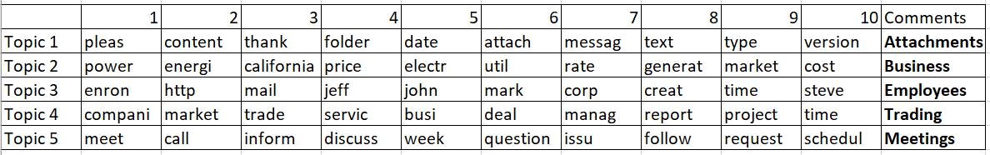

For k=5

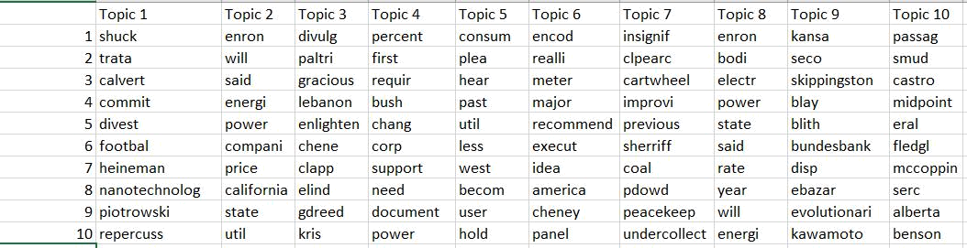

For k=10

Here I don’t know any label but still I labelled the data according to the words which appear in this. SO, according to me I categorized the data like above pic where I imagine that this can be a label of that topic.

The figure shows the results I received for K=5. As there were not a predefined category for this dataset it was hard to label each topic. The topic 3 contains terms like Jeff, John, and mark so we can say that this topic represents the employees of the company. With terms meet, call, schedule in topic 5, it can be labelled as Meetings. similarly, other topics can also be labelled as business, attachments, and trading. Results were somewhat similar when I provided value for K other than 5.

Here is the sample example of the text file of the email dataset in which the emails were extracted. I have some snippets by which we can have idea about the conversation between Enron employees through emails.

“Here I don’t know any label but still I labelled the data according to the words which appear in this. SO, according to me I categorized the data like above pic where I imagine that this can be a label of that topic.”

“Jeff The toad doesn t know how to please your wife Here is my friend Marc s e mail marc sondheimer quokka com When you pull a squirrel out of the water try and sell him bandwith Sean”

“Thanks I ll soften the expropriation language I don t think they can disclose the 1 million on the product liability case since the entire package appears to be one negotation all the pieces of which likely have to be agreed to or no settlement But you re point s well taken and I ll try to acount for it in the answer Finally I can t see disclosing the fact that I m infringing on someone s patent in my annual report Seems like I d have a hard time defending myself in court if they sued me if I d admitted it to it in my annual report ”

Word2Vec:

I train the text file of Enron email dataset and then I try to search words and figure out top 20 words which are similar with that words. I try it for different words and I give 10 words from that 20 words. The results are as below:

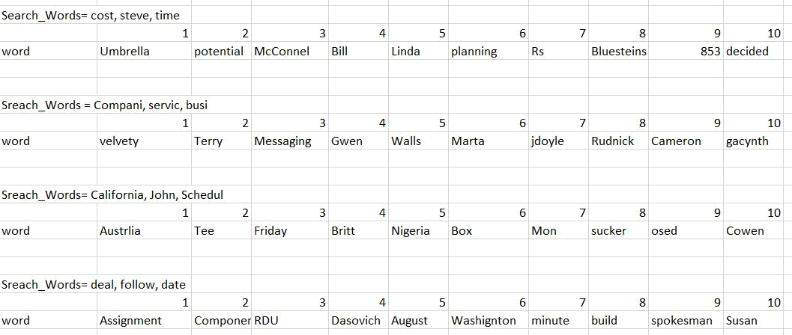

When I am searching for words “cost, steve, time” it gives me output like Bill, RS, 853, ,minute which terms are related . For example, RS and 853 is related to cost similarly Bill is related to John at last minute is related to time. So word2vec is giving proper output. When I am searching for words “company , service, busi” I get results related to this three words.

When I search for words “California, John, Schedule” then I get the output which is related to this words for example Austrlia and Nigeria are related to California, Britt is related to John, Mon and Friday are related to schedule, so we got the perfect results .When I am searching the words “deal, follow,date” it gives me term related to these words as the output. Which is accurate as deal is connected with assignment and build, date is connected to August, minute.

The main results from which I got the above-mentioned result is as below:

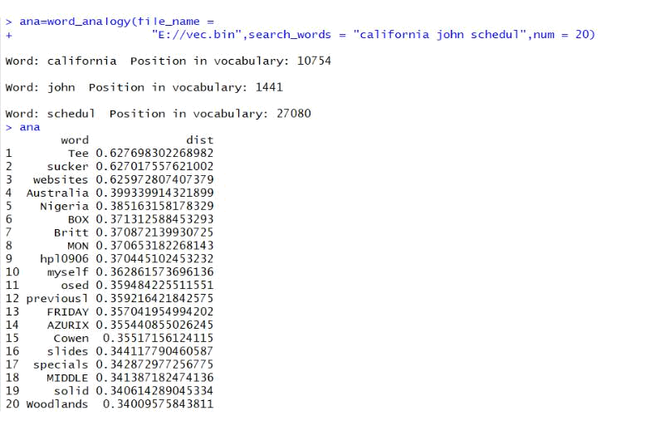

Similarly, I got results for the other search words.

Wordcloud:

I also plot Wordcloud for both of the dataset so that we can see the terms which appears in the dataset. So the wordcloud for both Enron email and yelp dataset is as below:

For Yelp dataset:

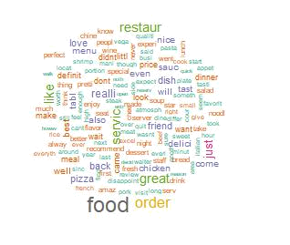

For Enron Email dataset:

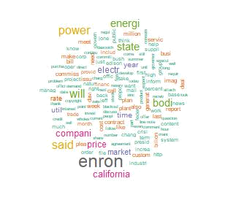

freq <- sort(colSums(dms), decreasing = TRUE)

dark2 <- brewer.pal(8, "Dark2")

wordcloud(names(freq), freq, max.words=100, rot.per=0.2,colors=dark2)

VII) Analysis/Learning/Challenges:

-The dataset used for the analysis was yelp dataset and Enron Email dataset which is huge and with different characteristics. Firstly the data is pre-processed and stored into another files.

- Pruning words by frequency i.e. removing words which occur less frequently is a better way to prepare the data for analysis. This will reduce the size of data and will make it easier for computation.

- LDA did perform well on the dataset and represented topics in a fairly better way. Although word2vec model does not provide topics, we can search for the different words and get similar words as output.

- During the entire procedure, upon comparing the influence of simplest of procedures like pruning, labeling, tf-idf weighting, formation of document-term matrix etc. provided a deeper understanding of the concepts. And to label the data which does not contain any label is also tuff.

- Yelp dataset and Enron email dataset are very huge dataset, so loading entire dataset, converting it to .csv format and reducing the data took time and effort.

- Once dataset was obtained, due to its large volume it became too tuff to train the models and get the result as system keeps crashing.

- The main Problem which I get in this project is that to give labels to the terms which is not even label values. As I am using “word2vec” and “LDA”. And this both methods are working properly as we do not have any error. It will get slow only if you using the whole file together as it has so many class.

-It slows down your processor when you increase size of the input files. And it is not working well because of the system configuration if you have highly configured system then this problem will not arise.

XI) Conclusion:

- The LDA learns a document vector that predicts words inside of that document and cluster words that tend to co-occur together into interpretable topics.

- This can be seen in the results we got for Yelp dataset and can be verified with the sub category of cuisine types chosen.

- In word2vec by training the model on a large corpus, word embeddings with encoded semantic information can be obtained

- The word2vec model learns a word vector that predicts context words across different documents.

- Based on our experiment results we can say that LDA is more suitable for Sentiment analysis and word2vec is for Semantic analysis

